OCEAN Self Nomination Process:
- Login to OCEAN dashboard- https://ocean.in.capgemini.com/Community/Index
- Click on OCEAN Nomination Self Nomination.

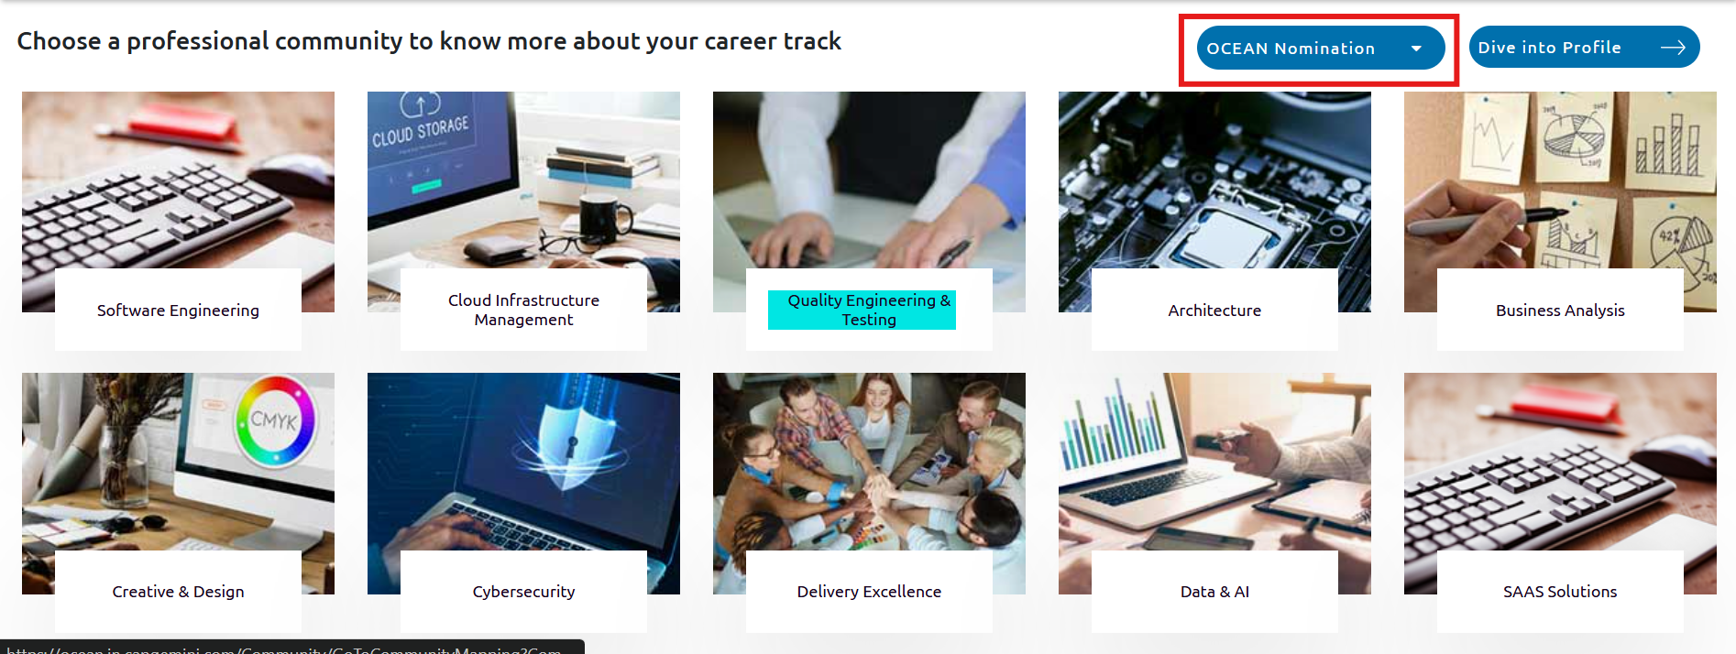

- Select the Professional Community which you belong to as per you primary skill
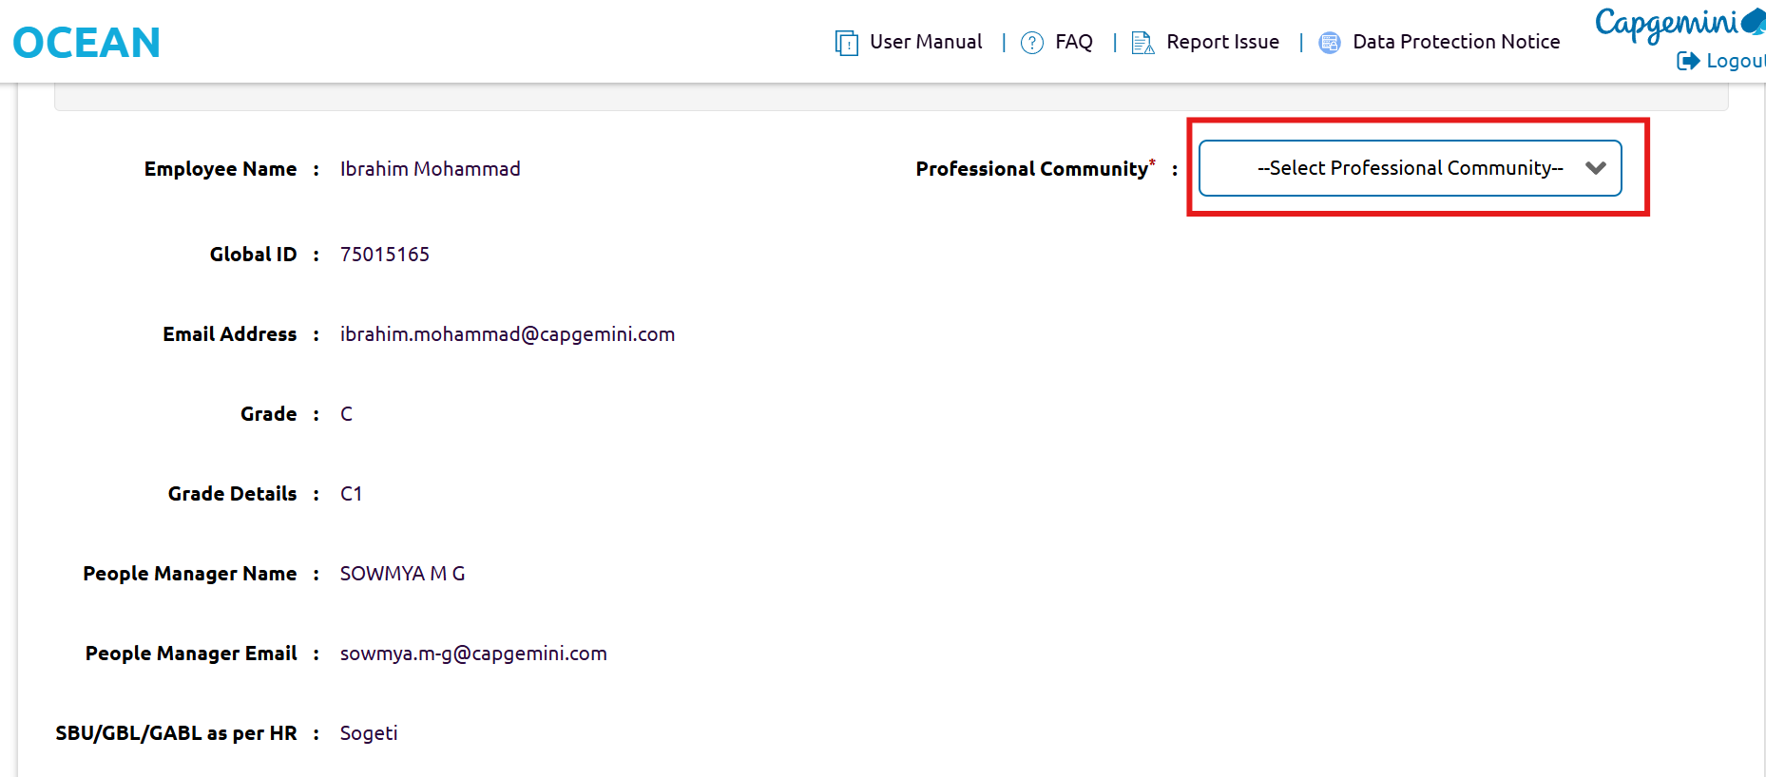

- Select Skill type, Skill group, Skill based on your skill- select any.

Note: It is advised to walk through all the options from Professional Community to Skill and select the best as per your primary skills.

